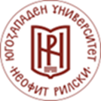  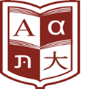

Dear colleagues,

We are pleased to invite you to the fifth consecutive **scientific conference “Linguistics: History, Challenges, Perspectives”**, organised by the Department of Bulgarian Language at the Faculty of Philology, South-West University “Neofit Rilski” – Blagoevgrad.

The scientific forum will take place in Blagoevgrad on **2nd and 3rd October 2025**.

*A round table on the topic “The Bulgarian Language Abroad” will be organised as part of the conference.*

The event is part of the National Scientific Programme “Development and Promotion of Bulgarian Studies Abroad”.

We look forward to receiving your **applications for the conference and/or the round table by 31st May 2025** at the following email: [**lingvistika@swu.bg**](mailto:lingvistika@swu.bg)

Please find the registration forms, in both Bulgarian and English, attached.

Kind regards,

The Organising Committee